Day 1 Assignment
Abhinaash Tiwari
1 December 2025
Tasks:
- Install MS SQL Server and Management Studio.
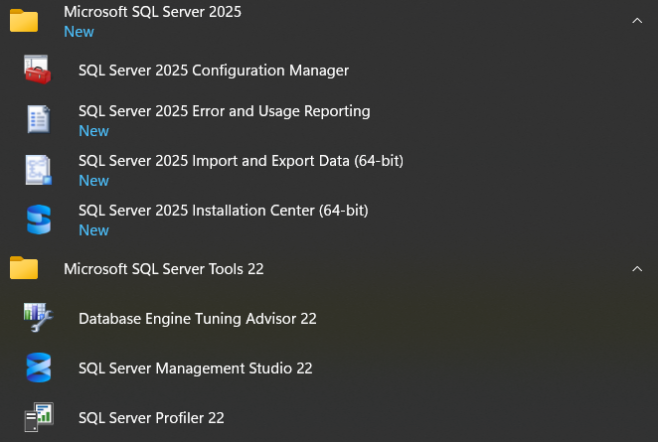
- Create a database named TrainingDB.
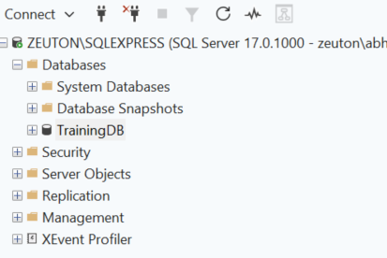
- Create a table Employees with columns: EmployeeId (PK), FirstName, LastName, Salary.
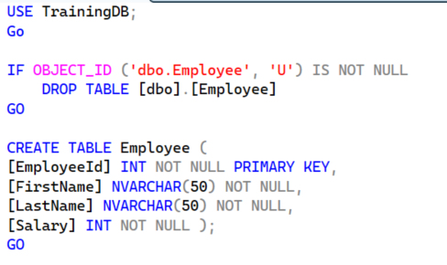
- Insert 3 sample records.

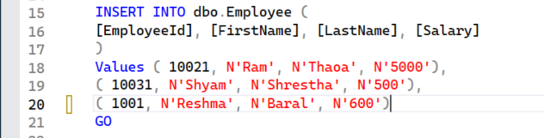
- Write SELECT queries to retrieve all records and specific columns.
